## **Project “Sea Elf” 1.5-Page GDD**

*Dink smallwood meets LoL meets Torchlight*

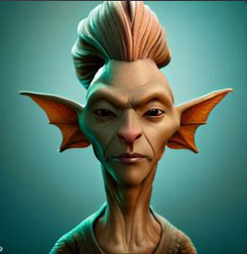 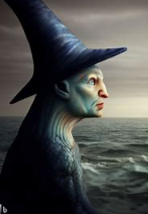 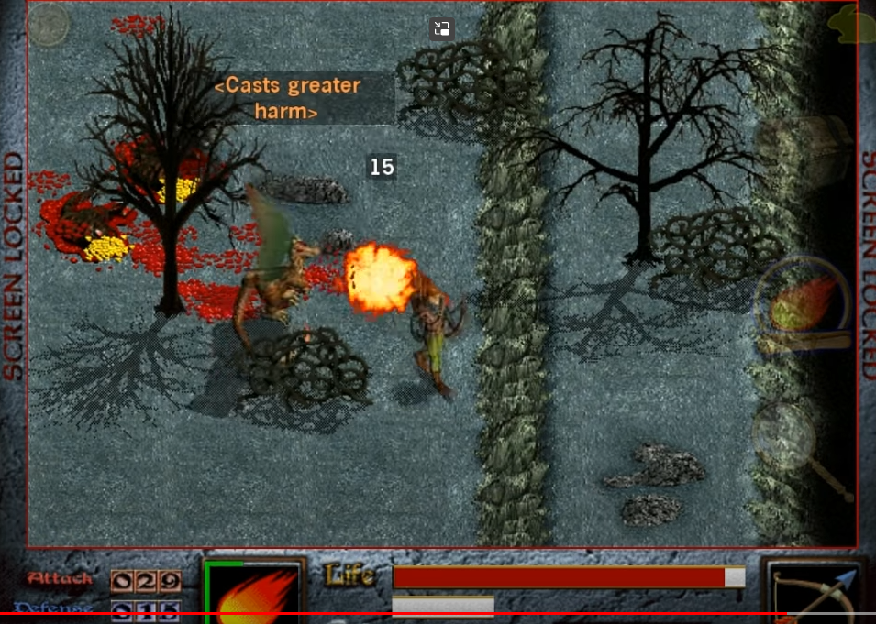

**Genre:**

3rd Person action, RPG, single player with maybe two characters if possible, fixed camera

**Target Audience:**

Game for all... Old school RPG with a silly sense of humour.

**Controls:**

Mouse, Keyboard

**Thematic Setting:**

Medieval, underwater battles lots of sea battles.

**Tech Stack:** Unity, Reaper for music, 3D assets from blender or from unity store

**Platform(s):** Steam

**MVP Game Moment:** A couple of enemy types, battles and basic progression through a couple of scenes. Simple Sandbox demo

**Game Summary:** "Reclaim the seas" becomes the rallying cry as Maglomil and his allies strive to overthrow the tyrannical overlords, the tyrants of the desserts mountains. Restore peace and harmony to the once-thriving underwater world. The fate of the seas and its inhabitants hangs in the balance as players join Maglomil on this epic and unforgettable journey.

**Core Player Experience:** Silly, Curiosity Open world discovery

**Central Story Theme:** Travel to multiple times to protect his seas

**Design Pillar:**

Stories, Combat,

**Remarkability:**

Story about environmental issues with a laugh.

**Anticipated Steam Early Access Launch date:**

A year May 2024?

**Feature Development Priorities:**

Coarse: I just following Rick and Sam for now

Real time combat

All the required RPG abilities

Level Building and game development

Branching Dialogue System

Inventory loot usable Items

**Reference Games:**

It takes two

Torchlight two

Diablo

Dark

Nemo

Battle Heart

Dink Smallwood